MicroHydroV1 – Tank Ripple Test Procedure
Document Type: Engineering Verification Test

Test Name: Ripple Attenuation Performance Test
Version | 1.0
Date | __________________
Prepared by | __________________
Approved by | __________________

1. Objective
Evaluate the ability of the MicroHydroV1 inlet system to reduce free‑surface ripple amplitude in a controlled water tank environment.
Performance Requirement: Ripple amplitude reduction of −30% to −50% compared to a baseline straight inlet under the same flow conditions.

2. Equipment and Materials
Item | Description / Notes
Water Tank | Sufficient length to allow inlet‑induced surface disturbance to develop (≥ 1.0 m recommended).
MicroHydroV1 Test Article | Complete inlet assembly mounted per PT mounting sketch.
Baseline Straight Inlet | Same diameter and flow capacity as MicroHydroV1 inlet.
Pressure Transducer (PT) | Mounted per PT mounting sketch; suitable for low‑frequency free‑surface fluctuation measurement.
DAQ / Logger | Minimum sampling frequency: 50–200 Hz. Must support PT calibration constants.
Flow Source | Pump or gravity feed with controllable flow rates.
Markers | Rulers/adhesive markers on tank wall for visual reference.
Stopwatch | Timing steady‑state intervals.
Calibration Sheet | PT calibration constants and zero‑offset reference.

3. Test Setup

3.1 Mechanical Setup
- Install the MicroHydroV1 inlet in the tank using the designated fixture.
- Install the Pressure Transducer (PT) per the PT mounting sketch: diaphragm downward into water; fixed depth 5–20 mm below nominal surface; provide strain relief.
- Place visual markers along the tank wall at known heights for optical verification.

3.2 Electrical Setup
- Connect PT to DAQ/logger using shielded cabling.
- Enter PT calibration constants (sensitivity and offset).
- Verify grounding to minimize noise.

3.3 Baseline Conditions
Water depth | __________________
Temperature | __________________
Flow rate range | __________________
Ambient lighting | __________________

4. Test Procedure (Step-by-Step)

4.1 Pre‑Test Checks
- Confirm tank is filled to nominal depth.
- Verify PT zero reading out of water.
- Submerge PT to test depth; confirm stable reading.
- Verify DAQ is recording at chosen sampling rate.

4.2 Baseline Straight Inlet Test
- Install the straight inlet.
- Set flow source to Flow Rate 1 and allow 30–60 s to stabilize.
- Record ≥ 20 s of PT data.
- Repeat for all planned flow rates (FR1…FRn).
- Save files as: Baseline_FR1, Baseline_FR2, …

4.3 MicroHydroV1 Ripple Test
- Replace straight inlet with MicroHydroV1 inlet assembly.
- Repeat Section 4.2 for identical flow rates.
- Save files as: MHV1_FR1, MHV1_FR2, …

4.4 Optional Visual Observation
- Place camera orthogonal to tank wall markers.
- Record 10–20 s of footage per flow rate.
- Note any vortexing, sloshing, or asymmetric disturbances.

4.5 Post‑Test Tasks
- Perform PT zero‑check again to detect drift.
- Back up all datasets to repository.
- Drain or secure test facility.

5. Data Intake Fields

5.1 Test Metadata
Test operator | __________________
Date | __________________
Test article version | __________________
PT serial number | __________________
DAQ sampling rate | __________________
Water depth | __________________

5.2 Flow Conditions
Flow Rate ID | Target Flow (L/min) | Actual Flow (L/min) | Notes
FR1
FR2
FR3

5.3 PT Data Files
Condition | File Name | Duration (s) | Comments
Baseline FR1
Baseline FR2
MHV1 FR1
MHV1 FR2

5.4 Derived Values
Metric | Baseline | MicroHydroV1 | % Change
RMS Ripple Amplitude (Pa or mm)
Peak‑to‑Peak Ripple
Dominant Frequency (Hz)
Percentage Ripple Reduction Formula: %Reduction = (Ripple_baseline − Ripple_MHV1) / Ripple_baseline × 100%

6. Acceptance Criteria
Pass / Fail Requirements: For every tested flow rate, MicroHydroV1 must achieve 30% to 50% reduction in RMS ripple amplitude relative to baseline.
Additional Observations | Requirement
Vortex formation | Not allowed
Asymmetric oscillations | Not allowed
Sudden pressure spikes | ≤ 10% of mean

7. How to Interpret Results
- Verify data quality: check for drift, spikes, and consistent noise floor. Apply low‑pass filtering (10–20 Hz) if necessary and documented.
- Extract metrics: RMS ripple amplitude (primary), Peak‑to‑Peak amplitude (worst‑case), Dominant frequency (stability indicator).
- Compute %Reduction = (Baseline − MHV1) / Baseline × 100%. Positive values indicate improvement; negative values indicate degradation.
- Compare against acceptance criteria: 30%–50% reduction is PASS. <30% or >50% is FAIL (investigate under‑ or over‑damping).
- Assess qualitative indicators: no vortexing, no asymmetric oscillations, no spikes >10% of mean, stable dominant frequency.
- Evaluate across flow rates: MicroHydroV1 must pass at each tested flow condition.

8. Examples of Result Interpretations
PASS (Within Target)
Baseline RMS 12.4 mm; MHV1 RMS 7.1 mm → 42.7% reduction. No vortexing; stable 1.8 Hz dominant frequency. PASS.
FAIL (Insufficient Reduction)
Baseline RMS 9.8 mm; MHV1 RMS 8.9 mm → 9.2% reduction. Asymmetric sloshing and spikes observed. FAIL; check alignment and pump transients.
FAIL (Over‑Reduction)
Baseline RMS 10.2 mm; MHV1 RMS 3.8 mm → 62.7% reduction (>50%). Possible flow choking or PT depth error. FAIL.
FAIL (Worse Than Baseline)
Baseline RMS 6.4 mm; MHV1 RMS 7.2 mm → −12.5% (degradation). Vortex observed; redesign or setup correction required.
Borderline – Engineering Judgment
Baseline RMS 14.0 mm; MHV1 RMS 10.1 mm → 27.8% (below 30%). Stable behavior; repeat run to confirm before concluding FAIL.

9. Glossary of Terms
Term | Definition
Baseline Inlet (Straight Inlet) | Reference tube geometry establishing uncontrolled ripple condition.
DAQ (Data Acquisition System) | Hardware that samples/logs sensor outputs (50–200 Hz sampling for this test).
Dominant Frequency | Main oscillation frequency in the ripple spectrum.
Flow Rate | Volumetric inflow to the tank (L/min), held constant between comparisons.
Free‑Surface Ripple | Surface undulations induced by inlet disturbances/turbulence.
MicroHydroV1 Inlet | Test article designed to reduce ripple amplitude.
Peak‑to‑Peak (P‑P) Amplitude | Max minus min within a time window.
Pressure Transducer (PT) | Sensor converting pressure fluctuations to electrical signal.
PT Calibration Constants | Sensitivity and offset used to convert voltage to pressure units.
Ripple Amplitude (RMS) | Root‑mean‑square pressure fluctuation magnitude.
Ripple Reduction Percentage | (Baseline − MHV1)/Baseline × 100%.
Steady‑State Condition | Period after a change when flow and ripple are consistent.
Vortex Formation | Undesirable swirling flow increasing disturbance.

10. Results Summary
Flow Rate | Reduction Achieved (%) | Pass/Fail | Notes
FR1
FR2
FR3

11. Signoff
Test Engineer | __________________ Date: __________
Engineering Reviewer | __________________ Date: __________

Appendix A – Visual Examples of Waveforms
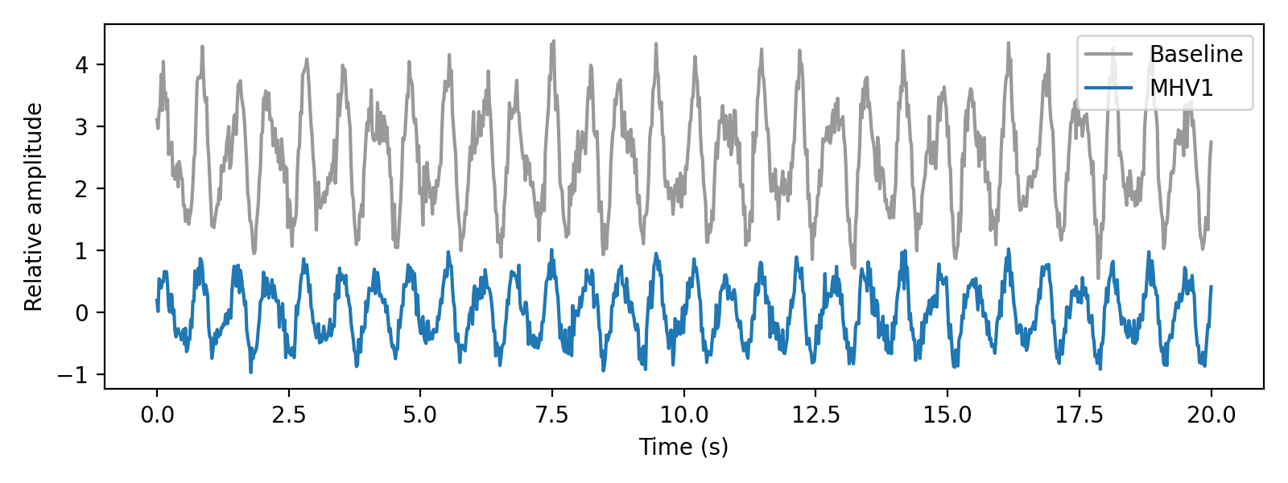
A1. PASS case: MicroHydroV1 ~40–45% reduction vs Baseline; similar dominant frequency; visibly lower amplitude.
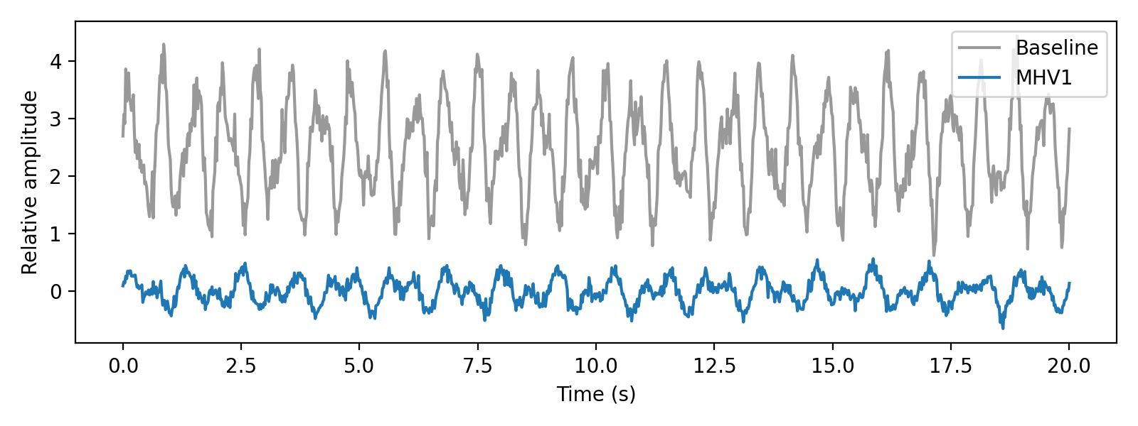
A2. Over‑damped case (>50% reduction): unusually flat waveform and frequency shift. Investigate choking/PT depth.
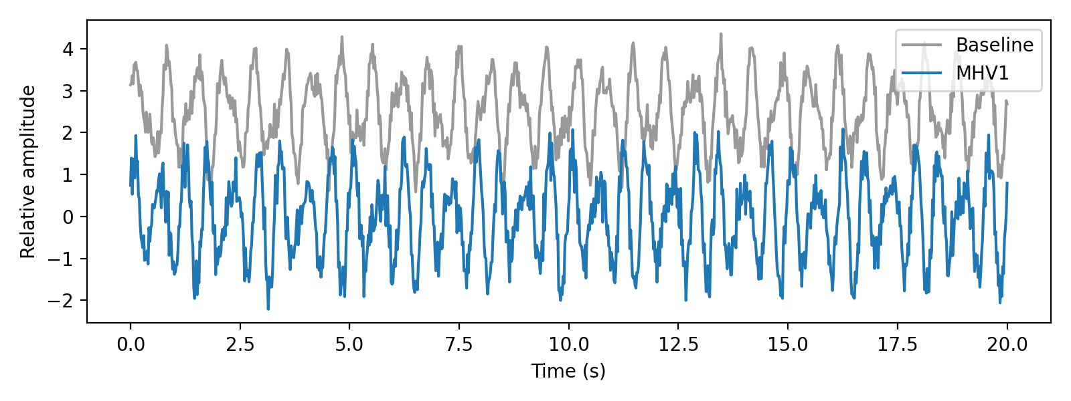
A3. Worse‑than‑baseline case: higher amplitude and irregular peaks; likely vortexing or setup issue.

